**Keys/Swipes/Fobs/Remotes Order Form**

**Fill in your details** (Please write clearly) System No: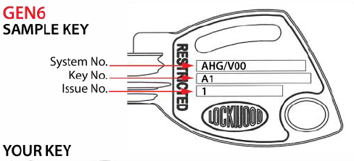

Key System Number: ……………………………….……………………. Key Code No:

Owner Name: TICK Ordered by agent or tenant (If not owner)

Unit No……………. Building Name or Address

Contact phone Number:/s.

SIGNATURE: …………………………………………………………………………………….………… DATE:

**Compulsory Full Address of Delivery**

Please indicate amount required:

|  |  |  |  |
| --- | --- | --- | --- |
| **Key** Inc. Postage |  | Quantity…………… x | $ 48.00 = …………... |
| **Garage Remote** Inc. Postage |  | Quantity…………… x | $ 140.00 = ……….... |
| **Fob** Inc. Postage |  | Quantity…………… x | $ 95.00 = …………. |
|  |  | **Total** | **$..........…………………** |

**Pre-payment is COMPULSORY no order will be released without prior payment and receipt sent to contact@priback.com.au**

**Bank Deposit** to Priback Strata **BSB**: 184-446 **Account Number**: 303759799

**Reference must state – UNIT NUMBER and Address of property**

**-----------------------------------------------------------------------------------------------------------------------------------------------------------------**

**Please Note – We cannot process Cheques or Credit Cards -- Deliveries-Australia Post take 7 to 10 business days**

***Please E-mail this Order form and the Bank Payment Receipt together in one email to***[contact@priback.com.au](mailto:contact@priback.com.au)

|  |  |  |  |
| --- | --- | --- | --- |
| Item Ordered | Date Paid | Ordered/Company Name | Date Posted by Priback  Date Posted by Careta |
| Key |  |  |  |
| Remote |  |  |  |
| Fob |  |  |  |